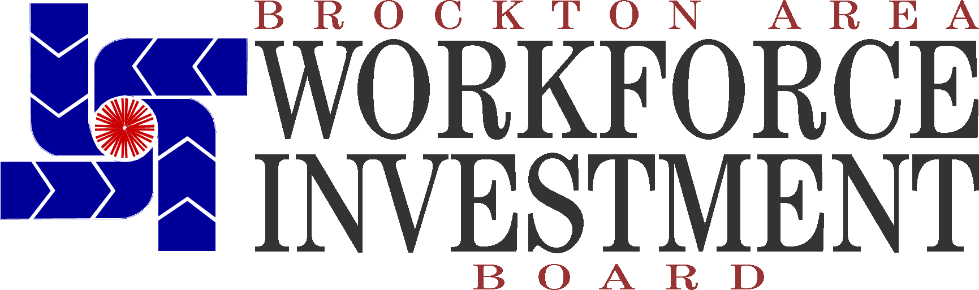
February 9, 2023

Dear Business Colleague,

MassHire Greater Brockton Workforce Board is very pleased to announce the 26th Annual Connecting Activities Partnership (CAP) Career Day being held on Thursday, April 13th, 2023, from 8:00 a.m. to 1:00 p.m. in the Multipurpose Auditorium at Teen Challenge in Brockton, MA! Co-sponsored by the Metro South Chamber of Commerce, this event with MassHire Greater Brockton YouthWorks is designed as an opportunity to build stronger connections between schools and the community. By connecting schools with area businesses and organizations, students can see the relevance and authenticity of what they are learning in school, invigorating the school culture and the classroom, while they begin to consider their potential careers. In addition, this day will include career readiness breakout sessions for high school students.

Students within the region will have the opportunity to explore careers in such areas as:
- Government, Court System and Law Enforcement
- Health and Science
- Information Technology
- Manufacturing and Construction Trades
- Retail
- Travel /Hospitality
- and much more

- Agriculture
- Animal Care
- Architecture
- Armed Services
- Arts, Media, and Communication
- Cosmetology
- Education and Human Services
- Finance, Business Management, Sales and Marketing

For your convenience, we have attached a Confirmation of Participation form with which you can advise us whether your business plans to participate. Each business will be provided with a display table, along with information on MassHire opportunities; electricity is limited but can be provided upon request. Please keep in mind that our intent is to provide students with information about careers in a variety of areas. We ask that your approach includes information on the education & skills required in your field and career pathways for your industry. We would be grateful for your response as soon as possible, but no later than Friday, March 17, 2023.

If you have any questions, please feel free to contact me at (508) 584-9800 x14.

Sincerely,

David Edwards

David Edwards
Connecting Activities Coordinator, MassHire Greater Brockton Workforce Board

Confirmation of Participation
Please return by Friday, March 17, 2023
The Connecting Activities Partnership Career Day
Thursday, April 13, 2023
Multipurpose Auditorium at Teen Challenge
1315 Main Street, Brockton, MA
8:00 a.m. - 1:00 p.m.
Fax: 508-584-9801 or Email: dedwards@masshiregbwb.org

YES, I will attend the 2023 Connecting Activities Partnership Career Day.
NO, I am unable to attend this year, but will send information for distribution.
NO, I am unable to attend this year.

If YES, please provide details to the following:

1. Company Name:

Please print your company or organization’s name the way in which you would like it to appear in our program materials.

2. Electricity:

Access to electricity is limited, but available upon request. (Please provide your own extension cord)

I will need electricity I will not need electricity

3. Name Tags:

Name tags will be provided for the staff at your table. Please list their names.

I have read the guidelines for The Connecting Activities Career Day as detailed on the next page.
Yes, here is my contact information is:

Contact Name:
Title: Email:
Telephone: Fax:
Address: Date:

The Connecting Activities Partnership Career Day Guidelines:

If you replied YES, thank you in advance for volunteering to participate in the Twenty-Sixth Annual CAP Career Day! This event will be held on Thursday, April 13, 2023, from 8:00 a.m. – 1:00 p.m. in the Multipurpose Auditorium at Teen Challenge located on 1315 Main Street in Brockton, MA.

We invite you, as a professional, to provide local high school underclassmen with information about careers in a variety of areas. We ask that your approach includes information on the education & skills required in your field and career pathways for your industry.

All businesses and organizations will be provided with a display table, along with information on MassHire opportunities. Please feel free to pass out any promotional materials that interested students can follow-up in the future, however, raffles will not be permitted.

Upon arrival, students will receive a “passport” listing the participating businesses and organizations. For students to be entered in various in-house prize drawings, they must visit a minimum of 8 presenters, ask a thoughtful question and have their “passport” initialed. Please kindly assist in facilitating this process.

If you have any special needs, concerns, or questions, please contact David Edwards, Connecting Activities Coordinator, at (508) 584-9800 x14 or email dedwards@masshiregbwb.org.

Thank you!

